nexo Retailer Listener
User guide – v2.1

References
Reference | Editor | Date or version
- Sale to POI specifications – Retailer protocol | Nexo | V3.0

Introduction
The Listener is a service provided along with the nexo classes which can be found on Github at https://github.com/pmespace/PMS.NEXO.
It is an executable software which can run on any Windows, Linux, mac OS computer supporting .NET 5.0 libraries.
Its role is to act as a gateway between any POS wishing to support nexo Retailer and any POI supporting nexo Retailer, avoiding for the POS to implement nexo Retailer.
The system works as follows :
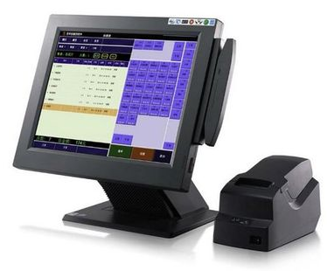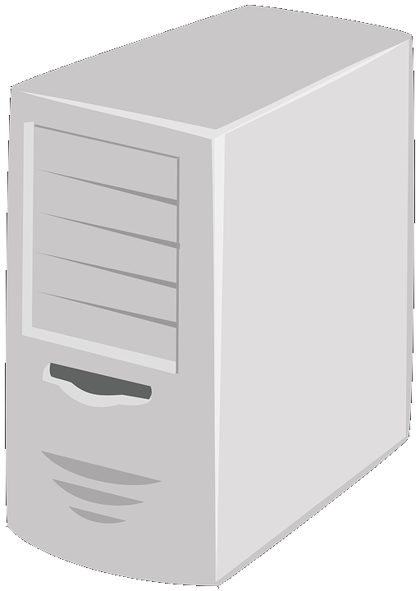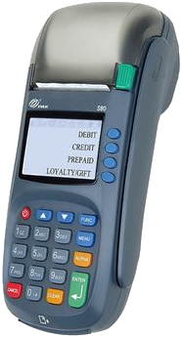
1. JSON
2. Listener
3. Retailer
Where:
- JSON
It is the interface between the POS and the Listener.
That interface is simple JSON file sent over a socket opened by the Listener; the POS must open that socket and send the JSON file instructing what kind of service must be addressed, using nexo Retailer, to the POI (terminal)
The JSON file format is described in §2.2.1 and §2.2.2.
- Listener
The Listener is an executable piece of software which opens a socket to receives commands from various POS and returns the result to the calling process. Commands are then outgoing (sent to the POI) and incoming (received from the POI). A description of both these commands can be found in §2.2.1 and §2.2.2.
- nexo Retailer
The nexo Retailer protocol itself, generated and understood by the Listener to send orders to the POI and receive results. A full description of this protocol can be found in [Sale to POI specifications – Retailer protocol].
The advantages of the Listener are therefore:
- To provide an easy abstraction of nexo Retailer without having to manipulate all its data and structures.
- The ability to deploy the Listener on a the local computer running the POS software or on a server allowing to centralise its processing and serving multiple POS.
- The ability to easily modify the data to send or receive to and from the POI.
The way to use the Listener is as follows:
- Listener is started on a computer
- The Listener uses a JSON settings file. This file is described in §2.1.
- The POS identifies the service it wants to operates on the POI (Login, Payment,…), retrieves the data it wants to set inside the request message, identifies which POI it wants to address and creates the JSON file to send over to the Listener.
- The POS opens the socket created by the Listener and sends the command (under a JSON file) and waits for the answer.
- The Listener receives the command, creates a nexo Retailer service as requested by the POS, sets the various data inside and sends it to the POI.
- The POI receives the request, processes it and returns the result to the caller (the Listener).
- The Listener receives the answer from the POI; it fetches the data the POS expects to receive and puts them inside a reply command.
- The reply command is sent back, as a JSON file, over the socket to the POS.
- The POS receives the JSON file and analyses it to know whether the operation was successful or not, eventually identify if data passed to be set have been set or not, eventually receives data from the reply from the POI, it they were present inside the reply sent by the POI.
Please note that the Listener whenever it receives a request from POS(1) to access a POI will make sure no access to the same POI from POS(2) is granted until the current request. Therefore accessing a POI is always serialised and put in a queue by the Listener ensuring a POI always serves one and only on POS at a time.
Listener however will not ensure serialisation between 2 service requests. To make sure a service is always fully completed the Listener must have AutoLoginLogout option set to true (refer to §2.1).
The following diagram describes how the Listener handles concurrent attempts to access the same POI:
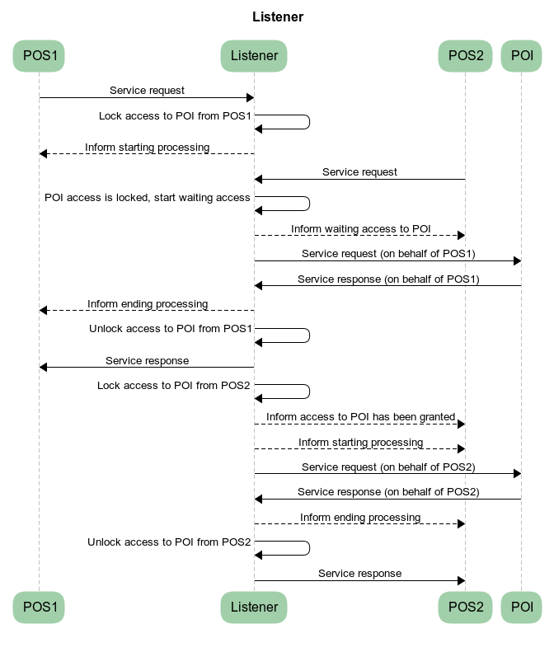

Reply and Notification messages
The Listener returns 2 types of messages to the POS:
- Reply messages
These messages are the responses to a request.
There are the final message returned by the Listener giving the result of the request.
In the above diagram they are the “Service response” ones with a fully drawn arrow.
- Notification messages
These messages are ones send by the Listener to provide information to the POS about the processing underway.
These messages must not be answered and can reach the POS unexpectedly.
In the above diagram they are (for instance) the “Inform starting process” ones with a dotted drawn arrow.
The POS is expected to receive and process these messages keeping until it receives the Reply messages which indicates the end of service processing.
They, for instance, inform the POI is being used by another POS, or indicates which step is currently being processed by the POI,...
To efficiently process these messages the POS must use the following algorithm:
if (ConnectToListener(Listener IP))
{
if (SendRequestToListener(Request))
{
while (null != (Reply = ReceiveFromListener()))
{
if (Reply.Notification)
// Notification, do appropriate processing (display message,...)
ProcessListenerNotificationMessage()
else
// Reply, stop reading messages from the Listener
break
}
}
DisconnectFromListener()
}

Interfaces
These interfaces are all JSON files (or structures) used by the Listener application.

Listener settings
Data | Type | Description
Port | Integer | The port the Listener will open on the computer to receive commands from a POS
AutoLoginLogout | Boolean | Indicates whether a Login/Logout nexo service must be sent to the POI before and after any other nexo service except Login or Logout.  Setting this option to true will ensure any service request will be considered as atomic and never disturbed by another request from another POS to the same POI. When set to true it becomes useless for a POS to send a Login and a Logout, concentrating on services.
AllowedIP | List of strings | A list TCP/IP addresses the Listener will accept commands from.  If the Listener is to be used from multiple POS all computers IP (v4) trying to reach it will have to be defined here.  The local address is defined by default and does not need to be added, that means the computer on which the Listener is installed can always send it commands without having to update the settings file.
AllowedServices | List of strings | A list of nexo Retailer services the Listener will accept to support and send a request to a POI.  The POI does not support all nexo Retailer services, where the Listener does. That list allows to follow the evolutions of the POI to declare which services are supported or not.  A service is declared using its name as indicated in [Sale to POI specifications – Retailer protocol].  The following services are although automatically defined and do not need to be defined (though they can):  - Login  - Logout  - Payment (allowing a normal payment and a refund)

Example
{
"Port": 29134,
"AutoLoginLogout": true,
"AllowedIP": ["192.168.1.12", "165.76.99.21"],
"AllowedServices": ["Reversal", "Reconciliation"]
}

Listener commands

Request
A request is sent by the POS to the Listener to request the activation of a nexo Retailer service.
Data | Type | Description
IP | String | The TCP/IP address of the POI to send the nexo service request to.
Port | Integer | The port to reach on the POI.
Service | String | The service to activate on the POS.  The name of the service is as found in [Sale to POI specifications – Retailer protocol].  Example: “Login”, “Reconciliation”,...
SaleID | String | The name of the POS (sale) as given by the POS.  That data is mandatory and will feed the MessageHeader.SaleID data in the nexo Retailer message. It is the name under which the POI knows the POS. Any value is valid but must remain consistent between a Login/Logout exchange.  For more information refer to [Sale to POI specifications – Retailer protocol].
POIID | String | The name of the POI (POIID) as given by the POS.  That data is mandatory and will feed the MessageHeader.POIID data in the nexo Retailer message. It is the name under which the POS knows the POI. Any value is valid but must remain consistent between a Login/Logout exchange.  For more information refer to [Sale to POI specifications – Retailer protocol].
ElementsToSend | Dictionary of Data Element | These are all the data elements the POS wishes to set inside the nexo Retailer service message.  For a full description refer to §2.2.3.
ElementsToReturn | Dictionary of Data Element | These are all the data elements the POS wishes to set inside the nexo Retailer service message.  For a full description refer to §2.2.3.
PaymentType | String | Indicates the type of payment to perform. For a list of payment types refer to [Sale to POI specifications – Retailer protocol].  Default value is “Normal”.  That option is not used if the service to run is not a payment.
RequestedAmount | Double | Amount of the transaction if one is required (payment or refund).  This is the amount that will be sent to the POI to perform the transaction.  That option is not used if the service to run is not a payment of any kind (including refund).
AuthorizedAmount | Double | Amount of the transaction if successfully processed.  This is the amount that has been returned by the POI after the transaction. It can differ from the RequestedAmount.  That option is not used if the service to run is not a payment of any kind (including refund).

Example
{
"IP": "172.21.48.1",
"Port": 2018,
"Service": "Login",
"SaleID": "SaleID",
"POIID": "POIID",
"PaymentType": "Normal",
"RequestedAmount": 1.0,
"AuthorizedAmount": 0.0,
"ElementsToSend": {
"LoginRequest.SaleSoftware.ManufacturerID": {
"Value": "MYSELF",
"Status": false
}
},
"ElementsToReturn": {
"LoginResponse.POISystemData.POISoftware.ManufacturerID": {
"Status": false
}
}
}

Reply
A reply is sent back by the Listener to the POS to inform it of the result of the previous request.
Data | Type | Description
ReplyStatus | Integer | A global status indicating how the request was processed.
  Value | Description
  0 | The nexo service was successfully completed  (Response.Result = Success)
  1 | The nexo service failed to complete  (Response.Result = Failure)
  2 | The nexo service failed to complete  (Response.Result = Partial)
  The following error codes imply the nexo service wasn’t processed
  3 | No special error was detected.
  4 | Request service is not supported by the Listener
  5 | A mandatory object is not present
  6 | The request is invalid and can’t be processed
  7 | The service is invalid (it doesn’t exist)
  8 | Invalid POIID
  9 | Invalid SaleID
  10 | A value is invalid
  11 | Failed to connect to the POI; check the IP address and port number
  12 | Error during the exchange; check log file
  13 | Timeout during the exchange; the reply has not been received in time
  14 | Cancelled; the operation was cancelled by the user
  15 | Unknown error
  Notification messages
  100 | Feneric notification message
  101 | The of POI is being used and the POS is being put on hold waiting to be granted access
  102 | The POS has been granted access to the POI
  500 | Performing Login
  501 | Performing Logout
  502 | Start Normal Payment
  503 | Normal Payment has ended
  504 | Starting Other Payment
  505 | Ending Other Payment
  506 | Starting Refund
  507 | Ending Refund
  508 | Starting Reversal
  509 | Ending Reversal
  510 | Starting Reconciliation
  511 | Ending Reconciliation
  512 | Starting Abort
  513 | Ending Abort
  514 | Starting another (undefined) Service
  515 | Ending another (undefined) Service
Label | String | The status in a text format
Message | String | A message describing the final result
NexoError | String | The contain of the Reponse.ErrorCondition data element inside the nexo Retailer service reply.  For more information refer to [Sale to POI specifications – Retailer protocol].  Not set if Notification message.
NexoInformation | String | The contain of the Reponse.AdditionalResponse data element inside the nexo Retailer service reply.  For more information refer to [Sale to POI specifications – Retailer protocol].  Not set if Notification message.
Request | The Request command | This is the request command as received by the Listener augmented with information about ElementsToSend and ElementsToReturn processing.  For a full description refer to §2.2.3.  Not set if Notification message.
Notification | Boolean | Indicates whether the message is a notification or not.  Refer to §1.1 for full description.

Example
{
"Notification": false,
"Status": 13,
"Label": "Success",
"Message": "SUCCESS processing Login service",
"NexoError": "2147483647",
"Request": {
"IP": "192.168.0.111",
"Port": 2018,
"Service": "Login",
"SaleID": "SaleID",
"POIID": "POIID",
"ElementsToSend": {
"LoginRequest.SaleSoftware.ManufacturerID": {
"Value": "MYSELF",
"Status": true
}
},
"ElementsToReturn": {
"LoginResponse.POISystemData.POISoftware.ManufacturerID": {
"Value": "PMS.NEXO30",
"Status": true
}
}
}
}

Data Element
A data element is a data that will be exchanged between the POS and the Listener.
Each data element is composed of:
- A key
The key is a string describing the path to the data to either set in the request sent to the POI or retrieve from the reply received from the POI.
The path must declare every data by its name as declared inside the [Sale to POI specifications – Retailer protocol] and through which to go inside a request or reply to reach a data to set or retrieve. All intermediary data must be declared separated by a “.” (dot).
For instance, to set the manufacturer ID inside a login request the key shall be:
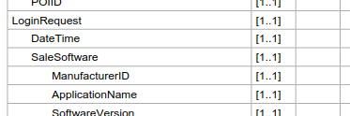
Key = LoginRequest.SaleSoftware.ManufacturerID
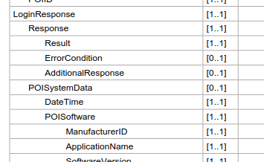
Key = LoginResponse.POISystemData.POISoftware.ManufacturerID
If the path does not point to a valid data, misses a node or adds an extra node, that data won’t be reached and won’t be set or retrieved.
The key is case insensitive.
Note: today the key doesn’t allow accessing an array item.
- A Data Element properties object
That object describes the value to set or retrieved and information about the success of the operation, as follows.
Data | Type | Description
Value | Object (string, numeric, boolean,...) | It can be any scalar data type (integer, boolean, numeric,…) or a string.  In ElementsToSend inside a Request  Meaningful, this is the value to set to the pointed data. It can be null.  In ElementsToSend inside a Reply  This is the value as specified in the Request command.  In ElementsToReturn inside a Request  Meaningless, it may be missing or set to any value which won’t be used.  In ElementsToReturn inside a Reply  Meaningful, this is the value as found inside the reply from the POI only if Status is true.
Status | Boolean | Indicates whether the data has been set or retrieved.  That data is always meaningless in a request as it describes the successful result of setting or retrieving the data inside the service messages.  In ElementsToSend and ElementsToReturn inside a Request  Meaningless, it may be missing or set to any value which won’t be used.  In ElementsToSend and ElementsToReturn inside a Reply  Meaningful, it indicates whether the data was set or retrieved successfully (true) or not (false).  Any data, inside a reply message, with a false indicator is therefore meaningless to the POS.
Message | String | Tries to give information about the error is the data has not been set or retrieved.  That data is always meaningless in a request as it describes and is meaning full only if the Status is false.

Example
"ElementsToSend": {
"LoginRequest.SaleSoftware.ManufacturerID": {
"Value": "MYSELF",
"Status": false
},
"LoginRequest.SaleSoftware2.ManufacturerID": {
"Value": "MYSELF",
"Status": false
}
},
"ElementsToReturn": {
"LoginResponse.POISystemData.POISoftware.ManufacturerID": {
"Status": false
},
"LoginResponse.POISystemData.POISoftware2.ManufacturerID": {
"Status": false
}
}
Elements in green are valid (refer to [Sale to POI specifications – Retailer protocol]) while elements in red are false (the path is invalid). They will give the following response inside the Reply message:
"ElementsToSend": {
"LoginRequest.SaleSoftware.ManufacturerID": {
"Value": "MYSELF",
"Status": true
},
"LoginRequest.SaleSoftware2.ManufacturerID": {
"Value": "MYSELF",
"Status": false,
"Message": "Failed settings data LoginRequest.SaleSoftware2.ManufacturerID with MYSELF"
}
},
"ElementsToReturn": {
"LoginResponse.POISystemData.POISoftware.ManufacturerID": {
"Value": "PMS.NEXO30",
"Status": true
},
"LoginResponse.POISystemData.POISoftware2.ManufacturerID": {
"Status": false,
"Message": "Failed fetching data LoginResponse.POISystemData.POISoftware2.ManufacturerID"
}
}

Default service values
When using services some values are set by default and do not need to be sent through the ElementsToSend structure. However, if any of these data is sent in the ElementsToSend structure, that value will be used instead of the default one. Here are some of these data set by default.
All services
ServiceID | Set with an hexadecimal value unique within a month
DeviceID | Set with an hexadecimal value unique within a month
Login Service
ManufacturerID | Set with values of determined with the value of PMS.NEXO30.xxx.dll
ApplicationName | Set with values of determined with the value of PMS.NEXO30.xxx.dll
SoftwareVersion | Set with values of determined with the value of PMS.NEXO30.xxx.dll
CertificationCode | Set with values of determined with the value of PMS.NEXO30.xxx.dll
Payment Service
SaleTransactionID.TransactionID | Set with an hexadecimal value unique within a month
SaleTransactionID.Timestamp | Set with the current date and time
PaymentTransaction.AmountsReq.Currency | Set with the default currency of the computer running the Listener (beware of the computer configuration)

Tested under Linux Ubuntu, Linux Mint (based on Ubuntu).
The software has not been tested under mac OS so far.

